Kinodvor. City cinema.
Ljubljana, Slovenia. Re-opened since October 1st 2008.
www.kinodvor.org
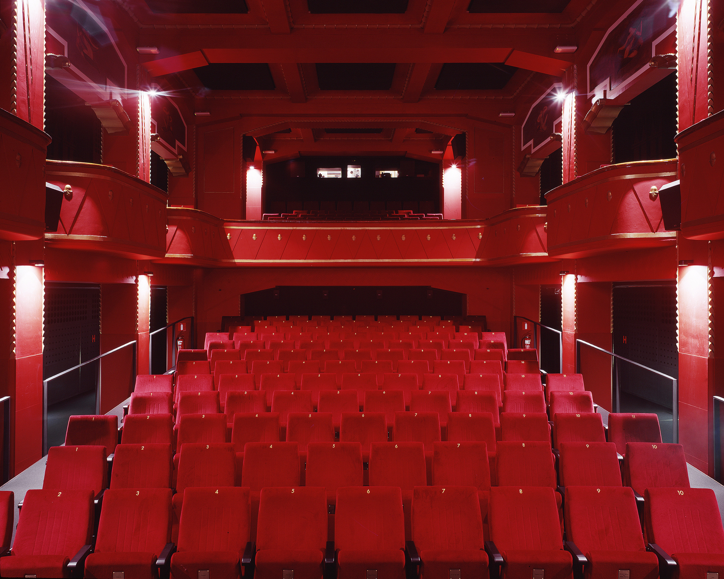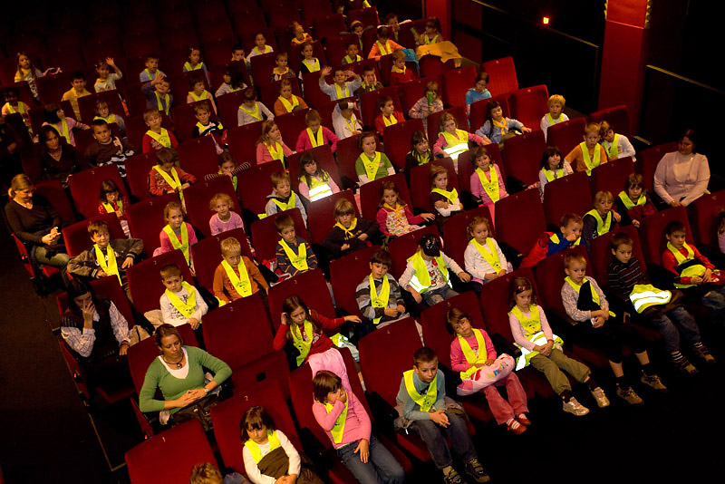
Kinodvor Young Audience

On October 1st the City of Ljubljana opened a new cinema: Kinodvor, the city's first and only municipal cinema dedicated to showcasing quality films and offering pedagogical and educational programs related to the audiovisual culture. Already within the opening month Kinodvor fulfilled its promises and the audiences' expectations. Four films were theatrically released in this period: intelligent British heist movie The Bank Job, Bosnian tragicomedy It's Hard To Be Nice, Slovene political documentary Dar Fur: War For Water and Hungarian feature length animation Egon & Dönci. Last title was shown as part of a special, ongoing program for younger audiences which included also multiple screenings if a specially selected program of short animated films and numerous workshops. Another part of this program: special morning screenings for schools, organized under expert guidance almost on a daily basis. Apart from regular theatrical releases, many special events took place in the cinema, ranging from unique opportunities such as a twelve-hour Halloween horror marathon of quality genre cinema to various live talks with many special guests, amongst others Srdjan Vuletic, the director of It's Hard To Be Nice, and Slobodan Sijan, legendary Serbian director, who currently exhibits his photographs (dedicated to 40th anniversary of Hitchcock's Vertigo) in Kinodvor's gallery space. Apart from one screening hall, gallery space and lobby-bar Kinodvor also includes the first specialized bookshop in Ljubljana. Total audience attendance in the first month: 7000.

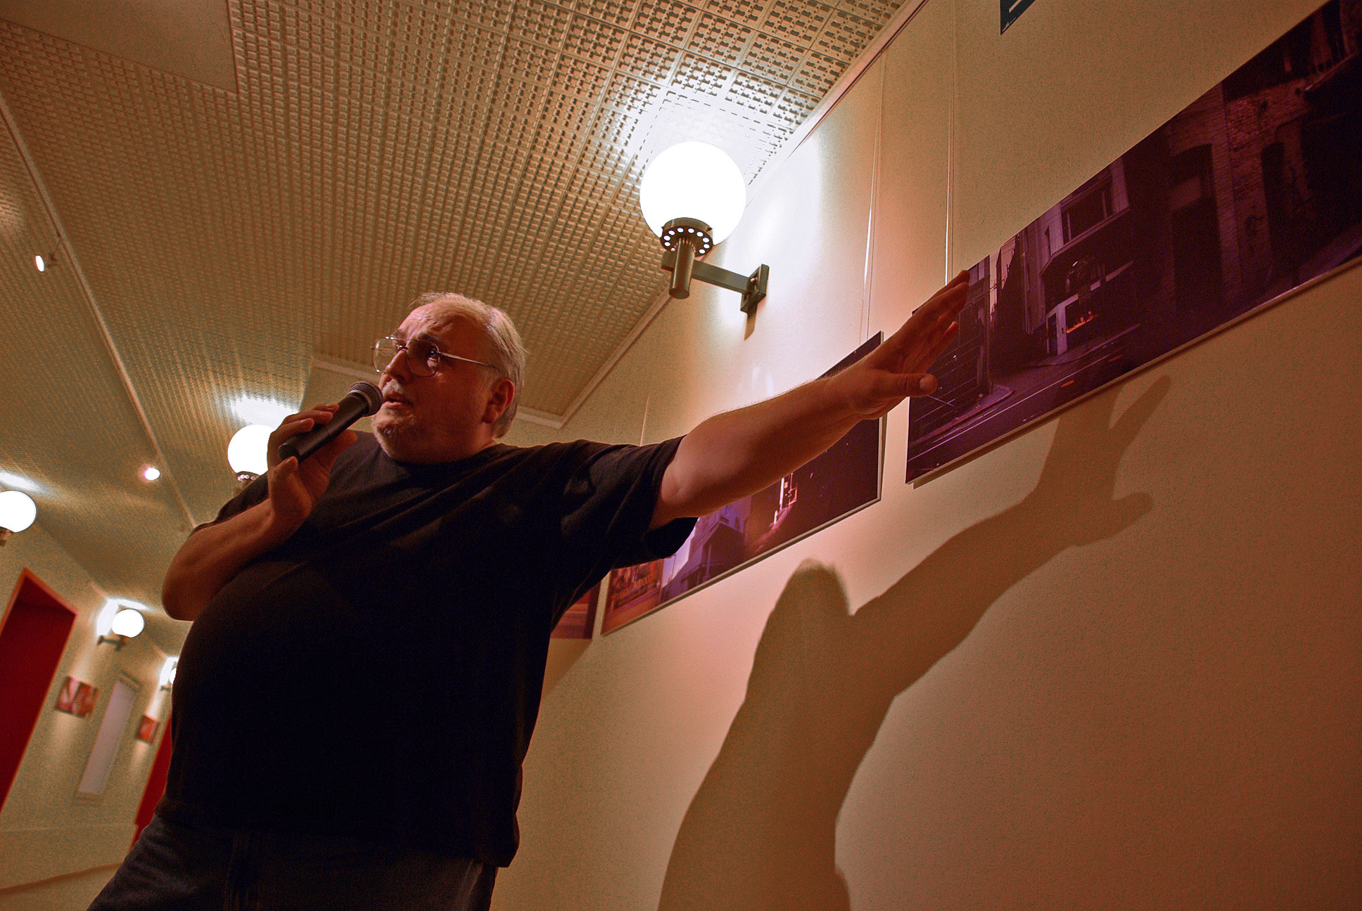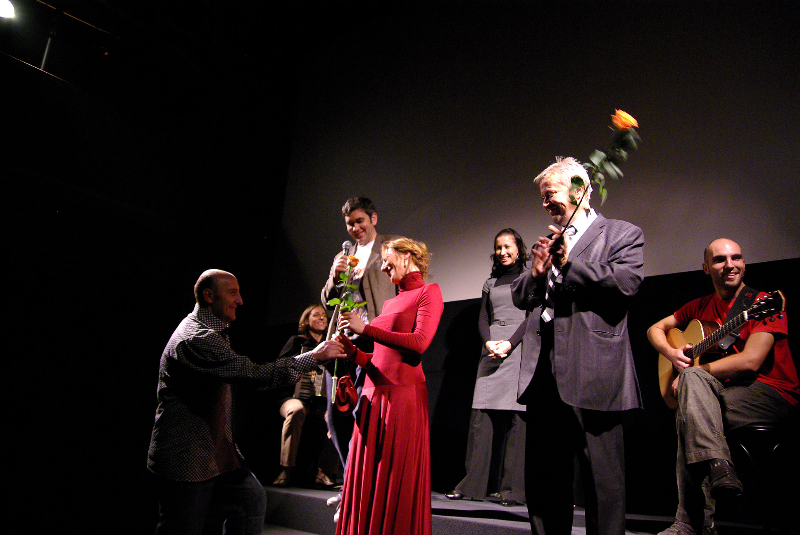
Slobodan Šijan It is hard to be nice film crew


Halloween horror marathon Workshops

